Incident Response Report: Red Team Simulation

1. Executive Summary
This engagement simulated a full-cycle security incident, encompassing initial exploitation, detection, and containment. The primary objective was to validate the effectiveness of current monitoring systems and the speed of the incident response team in isolating a compromised asset.

2. Attack Simulation & Findings
The simulation targeted a vulnerable Metasploitable2 environment. Using the Metasploit Framework, two critical vulnerabilities were exploited:
- VSFTPD v2.3.4 Backdoor (T1210): Allowed for instant root shell access.
- UnrealIRCd 3.2.8.1 Backdoor (T1190): Provided persistence and administrative control.
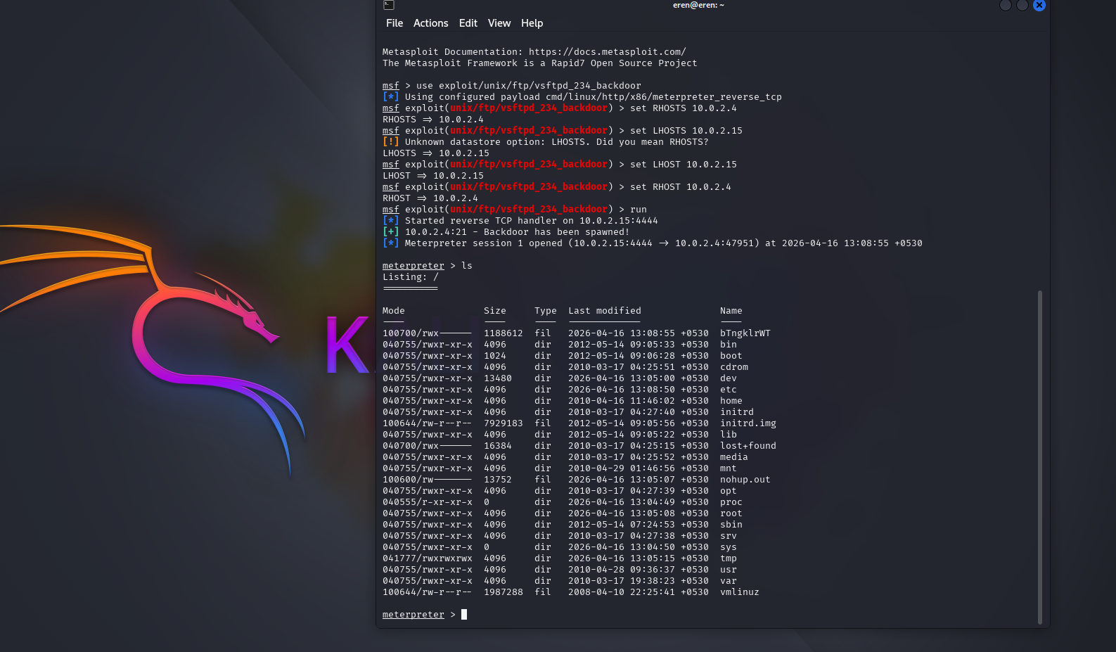
Fig 1 : VSFTPD v2.3.4 Backdoor (T1210)

3. Detection Phase (Wazuh)
Wazuh successfully captured the unauthorized process execution and the spawning of the root shell. The following log entries were recorded:
Timestamp | Source IP | Alert Description
2026-05-11 12:02:13 | 10.148.42.76 | UnrealIRCd Backdoor Exploitation
2026-04-17 12:30:05 | 10.0.2.15 | VSFTPD v2.3.4 Backdoor Execution
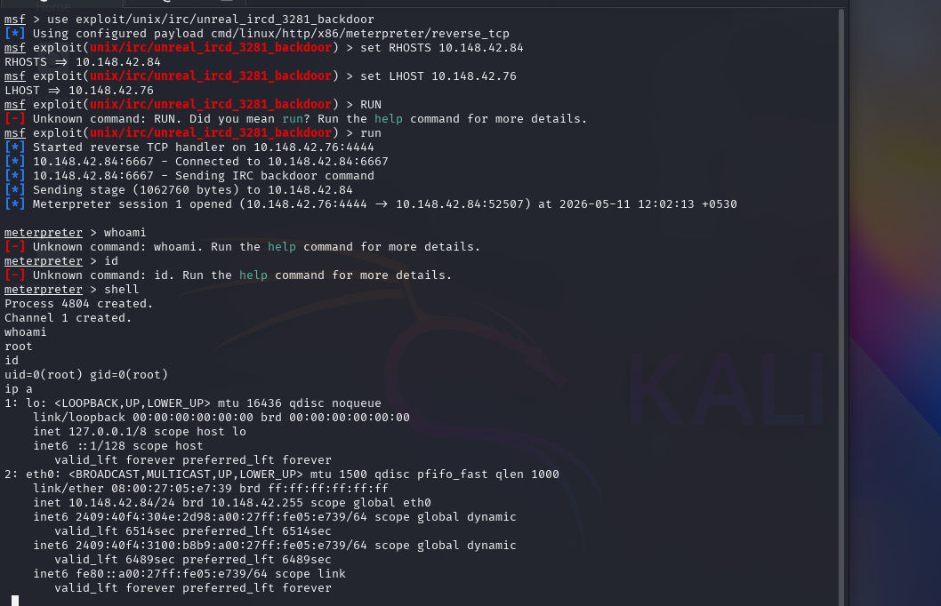
Fig 2 : UnrealIRCd 3.2.8.1 Backdoor (T1190)

4. Containment & Remediation
To contain the threat, the attacker's IP address (10.148.42.76) was blocked at the kernel level using the native firewall. This action simulated a CrowdSec remediation response.
sudo iptables -A INPUT -s 10.148.42.76 -j DROP
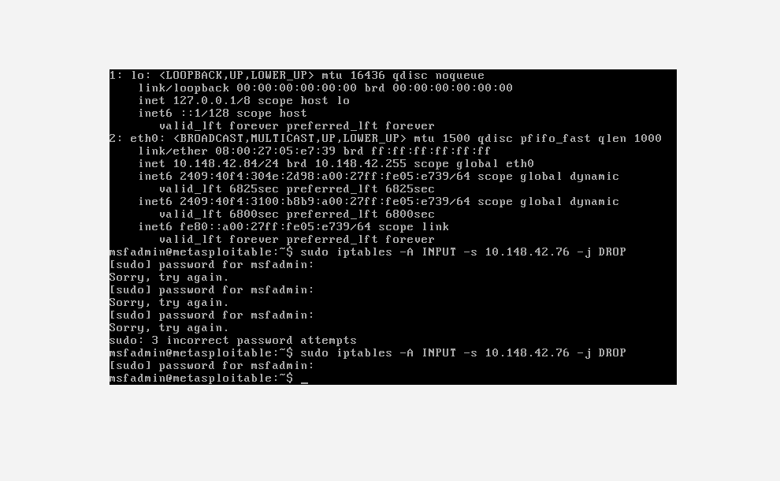
Fig 3: CrowdSec-style firewall containment implemented

5. Final Recommendations
- Update or replace legacy services that contain known backdoors.
- Implement automated IP blocking via CrowdSec for any IP triggering high-severity Wazuh alerts.
- Enforce the principle of least privilege across all system accounts to limit the impact of a compromised shell.
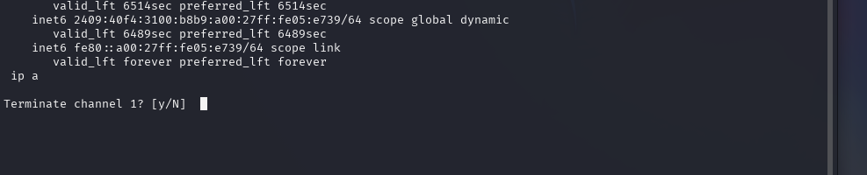
Fig 4: IP blocked by crowsec

6. Conclusion
This capstone project successfully demonstrated the complete incident response lifecycle including exploitation, detection, containment, and reporting. The exercise highlighted the importance of proactive monitoring, vulnerability management, and rapid containment strategies in defending systems against cyber threats.

